**ProjectPlanningPhase**

**ProjectPlanningTemplate(MilestoneActivity)**

|  |  |
| --- | --- |
| Date | 09/11/2022 |
| TeamID | PNT2022TMID07651 |
| ProjectName | Real-Time Communication System PoweredByAIFor SpeciallyAbled |

MilestoneActivityPlan.

|  |  |  |  |
| --- | --- | --- | --- |
| **Milestone** | **Function(Epic)** | **MilestoneStoryNumber** | **Story/Task** |
| **Milestone**1 | Datacollection | M1 | we're collecting dataset for building ourproject and creating two folders, one fortrainingand anotheronefortesting. |
| **Milestone 2** | Imagepreprocessing | M2 | Importing image data generator librariesand applying image data generatorfunctionalityto train the testset. |
| **Milestone 3** | Modelbuilding | M3 | Importing the model building libraries,Initializingthemodel,AddingConvolutionlayers, Adding the Pooling layers, Addingthe Flatten layers, Adding Dense layers,Compiling the model Fit and Save themodel. |
| **Milestone 4** | Testingthemodel | M4 | Import the packages first. Then we savethemodelandLoadthetestimage,preprocessitandpredictit. |
| **Milestone 5** | Applicationlayer | M5 | Build the flask application and the HTMLpages. |
| **Milestone 6** | TrainCNNmodel | M6 | RegisterforIBMCloudandtrainImageClassification Model. |
| **Milestone 7** | Finalresult | M7 | To ensure all the activities and resultingthe finaloutput. |

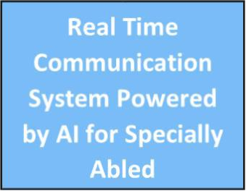

**FinalResult**

**Train CNNmodel**

**Applicationlayer**

**Testing themodel**

**Model Building**

**Imagepreprocessing**

**DataCollection**



**Loadthetestmodelimage,preprocessing andpredictit.**

**Importing themodel buildinglibraries**

**Importing theimagelibraries**

**Collectingdataset forbuildingproject**

**MachineLearning, CNN&RNN**

**JAVA &PYTHON**

**MySQL &NoSQL**

**TechnologyUsed**

Ensure allactivities &getting finaloutput

Register for trainimageclassification

Building flaskapplication